July 07, 2014
Seed Processing.
Don Pigott,
Yellow Point Propagation Ltd.

Introduction

The main objective of seed extraction and cleaning is to; reduce the bulk and weight by removing non-seed chaff or debris, and to put seed into a suitable condition for storage and/or sowing.
The principles of seed cleaning are to separate seeds and their associated structures into different fractions and retain only good, healthy, viable seeds. These fractions usually include;
-good, healthy, insect free, viable filled seeds
-find debris (smaller in size and lighter than seed)
-coarse debris (larger and heavier than seed)
-empty or insect damaged seeds

Drying
Most species are usually air dried or kiln dried to allow the structures or fruits to open through the loss of moisture. They are then shaken or tumbled to release the seeds. Some will species will shed their seeds at room temperature when laid out in thin layers on screens, or newspaper. Seeds can either be dried quickly in a kiln in 16-24 hours at 25-35 C depending on the species, or at room temperature for several days which is often safer. A dehumidifier in the room can also be beneficial.
Tumbling
During the tumbling, or shaking process there will be certain amount of non-seed debris released as well. This debris may consist of leaves, twigs, other plant parts, insects, dirt, or other foreign matter. The tumblers consist of a revolving drum that is covered with screen sized to allow mostly seeds to pass through, while the coarse or large debris is retained in the drum. Once the seed and small sized debris is removed, the coarse debris is dumped from the tumbler and disposed of.

Scalping or Screening
The seeds are then separated from the debris using different sizes of screens.The majority of the debris is removed in this manner. Depending on the volume of seed this separation can be done by either hand screens, or commercially available, mechanized vibrating screens.
Debearders
Debearders are rotating drums that agitate seeds which have awns, husks, and bristles. Hand screens can sometimes be used for that purpose as well
Air Separation
The remaining debris and empty seeds can then be removed by weight or specific gravity using an air separator. With an air separator, seed is slowly fed into a column of air. The velocity of the air can be adjusted so that the debris is removed while the heavier seeds are retained.

Fleshy Fruits
Seeds of fleshy-fruited species are removed by first macerating the fruit either manually or in a blender, macerator or modified juicer. There are also commercially available macerators specifically designed for seeds (Dybvig). Caution must be used on species with delicate seed coats to avoid injury. The duration of maceration is critical, only doing it as long as is necessary to separate the pulp from the seed. Frequent monitoring to ensure that seeds are not being damaged is advisable. The seeds and pulp are then first passed through screens to separate the seeds from the coarser pulp. Additional cleaning is achieved by floating off fine debris, juice and empty seeds in water. The principle is that the good heavier seeds sink, while the other fractions and empty seeds float. It may require several changes of water to decant off the debris. The seeds are then dried to a moisture content suitable for storage. The seeds can be dried by spreading them out on screens in a warm room, or the drying can be expedited by placing the seed in a cloth bag and spun in a clothes spinner, followed by several days on screens to dry. It can take several days to dry seed from fleshy fruits. Once dry, a final cleaning by air separation is often done.

Record Keeping
It is important to track the each collection made each year to enable you to; predict the collection cost for each species, as well the timing and yield

Seed Testing
Seed purity, moisture content, and germination can depend upon the species and end product usage. For expensive species, or those to be machine or precision sown, high-germination pure seed is required. For broadcast sowing over large areas, bulk may be advantageous, provided there are enough germinable seeds per unit volume.
Optimum moisture content for storage is generally between 5 – 10%.
Seed Storage
Seed storage condition requirements will vary by species, and by duration. Most species will store adequately at above freezing, but cool temperatures. ( 2-5 ⁰ C) For long term storage, sub-freezing temperatures are usually recommended,

EQUIPMENT

Drying
Most vegetables, fruits, and grains are harvested when the plants are mature. Some of the indicators of maturity include changes in colour, reduction of weight, and moisture content. The seeds usually still need some additional drying to be storable. A separate small room that can be heated and has good air movement is a good idea. Small rooms can be heated adequately with either electricity, or small oil furnaces which can be purchased used very reasonably, albeit require some form of chimney.
Dehumidifiers are useful to reduce the moisture content of the seed being dried. A 28 pint unit can be purchased in hardware or department stores for around $200

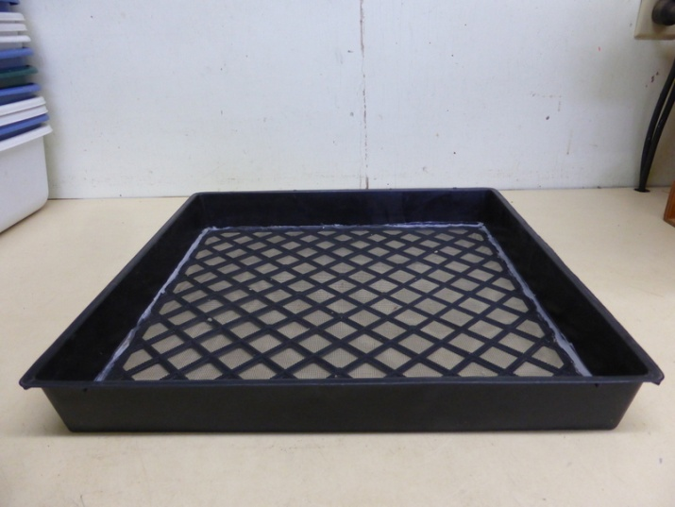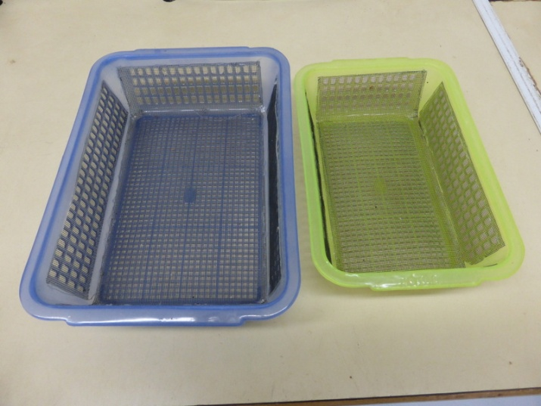
16” square nursery flats with Plastic containers from a Dollar store
door screen attached with a glue gun.

In both the above cases you need to suspend the trays so that there is adequate air flow around the seed in
order to dry properly. Air movement using small fans is useful.

Racking to support different seed trays or drying containers can be constructed of wood or iron, or they can
purchased at Home Depot, Costco, or Canadian Tire, for $75-$200 per unit.

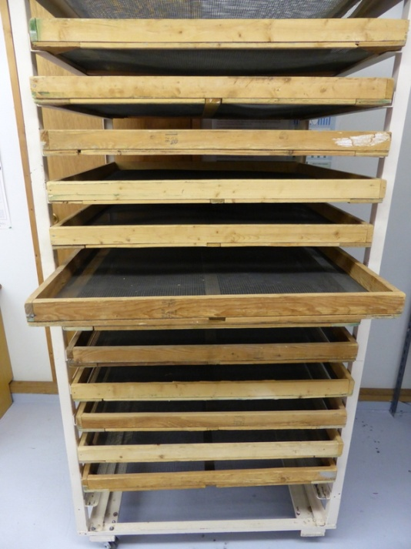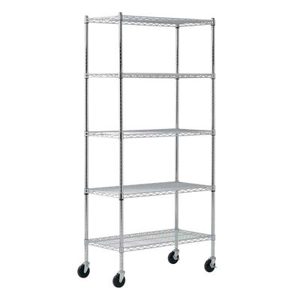

Movable racks made of angle iron. The wood- Sandusky Rolling Rack.
framed trays are made of 1x3’ spruce or pine 36” x18” x 72” high.
with small plywood gussets in the corners. Available at Home Depot.
They are 3’x3’. Screen door screen supported by Price: $92
hardware cloth is stretched over the frames and
are held in place by ¾” plywood strips..

Tumbling.

Small Tumbler.

This small tumbler is made from either ½” or 5/8” plywood. The motor was a gearhead motor from Princess Auto. The motor speed was 50 RPM and reduced to 40 using pulleys. It cost less than $50. They are no longer available. The alternatives are; use pulleys to reduce the speed of a conventional 1725 RPM motor similar to the larger tumbler; use a small DC motor with a speed control: purchase a more expensive gearhead motor. Total cost of materials for the small tumbler would be under $200.

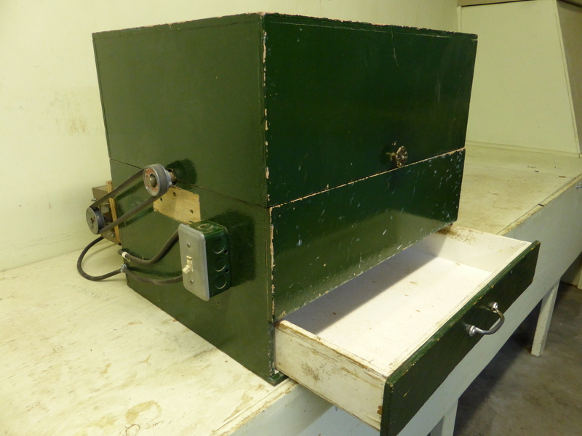

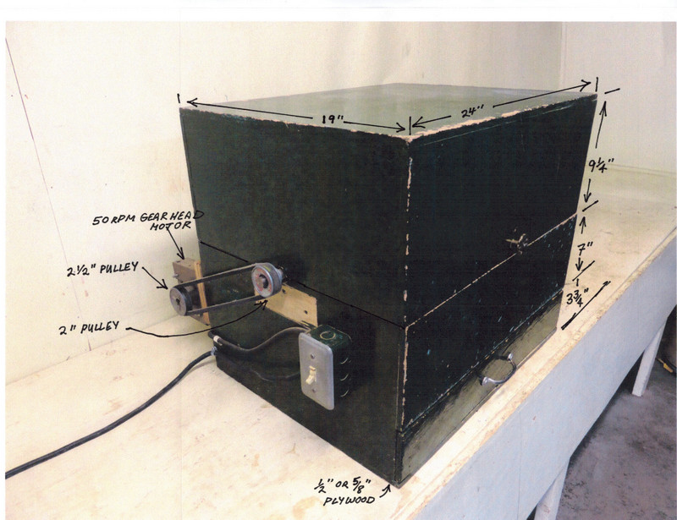

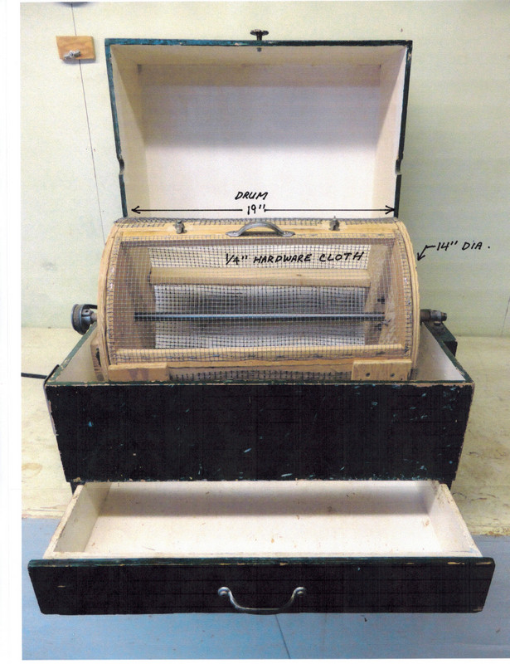

Large Tumbler

This large tumbler is more than adequate for most seed growers. There is a smaller drawer in the front to catch the seed. Once the seed is removed, the door on the drum can be removed, and the tumbler turned on again to spill the debris into the larger drawer at the bottom. The larger drawer is on casters or small wheels so it can be pulled out to make trash disposal easier. This tumbler is constructed of mostly 5/8” or ¾” plywood. Total cost of materials would be under $600.

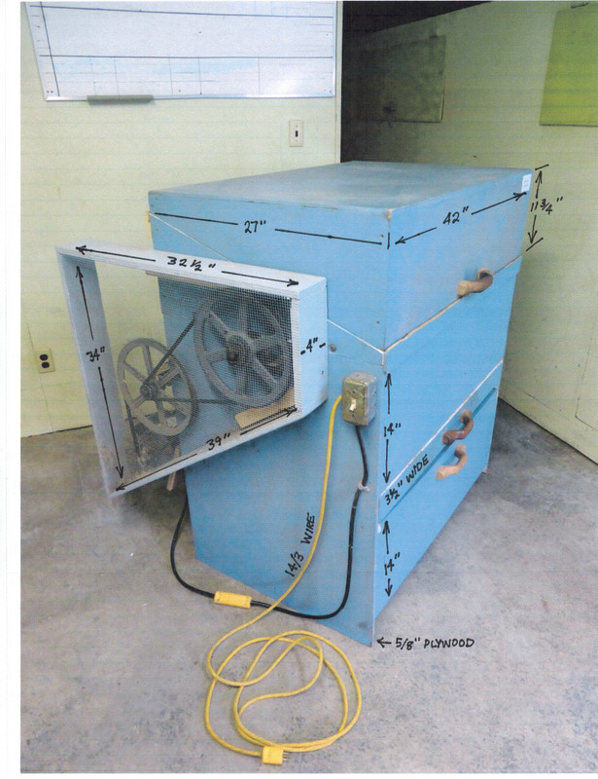

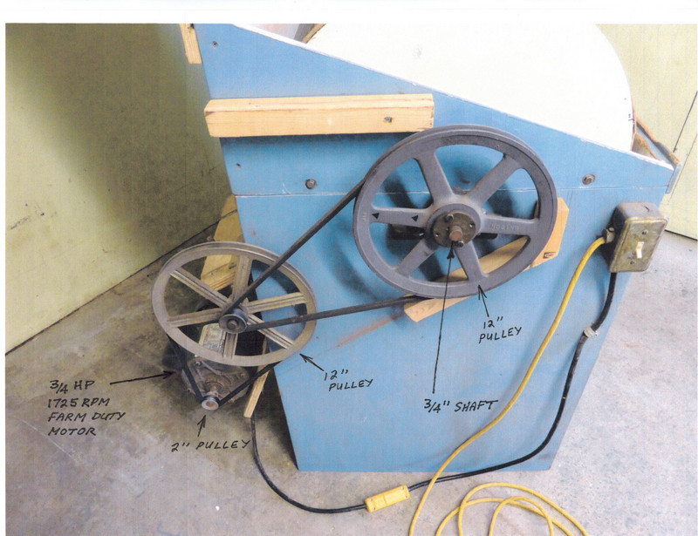

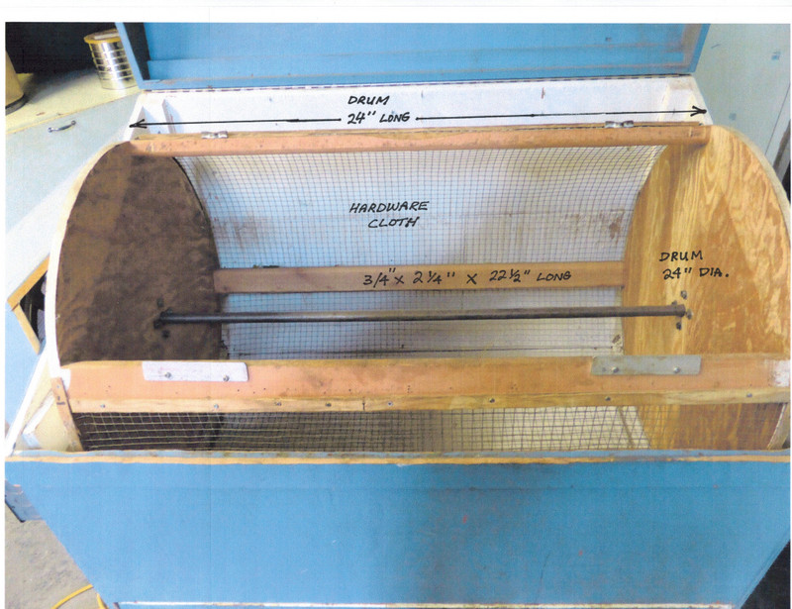

This tumbler has 3/8” hardware cloth. It is sometimes useful to have a couple
of different drums with different hole size. Note that the top (lid) is designed to
to be easily removed to repair or change the drums.

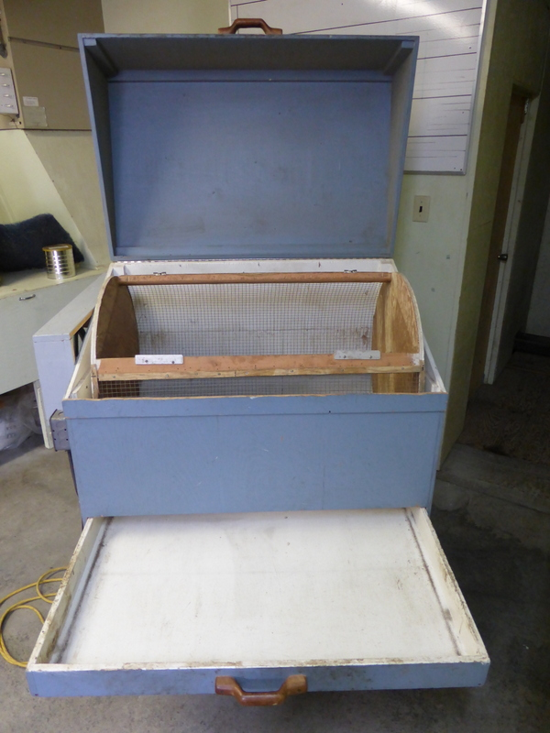

Screening

Hand screens

Hand screens can be very useful for separating the seeds from debris, particularly for smaller lots. These one are 11”x 12”. There are many different hole or opening sizes and configurations. Some have round holes, slotted holes or square holes. They are commercially available (12” x 12”) for about $40 US from Hoffman Manufacturing, not including exchange and shipping. I can probable supply you with most of the sizes from old surplus screens.

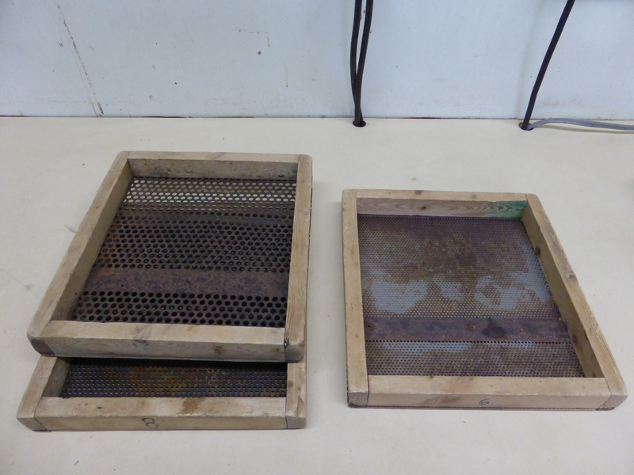

Seed Cleaners

Commercial seed cleaners are available from a number of sources, primarily in the USA . Basically, they have vibrating screen which separate the seed from the debris. They also have a fan to aid in removal of some of the lighter, unwanted fractions. The prices range from a low of $2195 US for the small, desk-top model , the Clipper Office Tester. It used to be available as a hand-crank model, but now they have either a 1/6th or 1/4 HP model. They are adequate for most small collections.
The next size up is the Clipper Eclipse 324 which has three screens. The cost starts at $6900 US, but does not include crating, ($250) extra screens, shipping or exchange. It may be possible to find used seed cleaners like the M2B. Check out “Used “ websites, and /or advertise that you are interested in purchasing one. There are several other manufacturers which can be found online, but those mentioned above are tried and proved, and probably the most cost efficient. Suppliers include;
Hoffman Manufacturing. www.Hoffmanmfg.com 1800-692-5962
Seedburo Co. www.seedburo.com 1800-284-5779
There are numerous others on the internet.

Debearders

A definition of the term "debearder," which means, in seed pre-cleaning procedures, that it has a hammering or flailing action that removes awns, beards, or lint from seed and tends to break up seed clusters of the chaffy grasses. This lab debearder available at Hoffman sells for $3500 US plus shipping, etc.

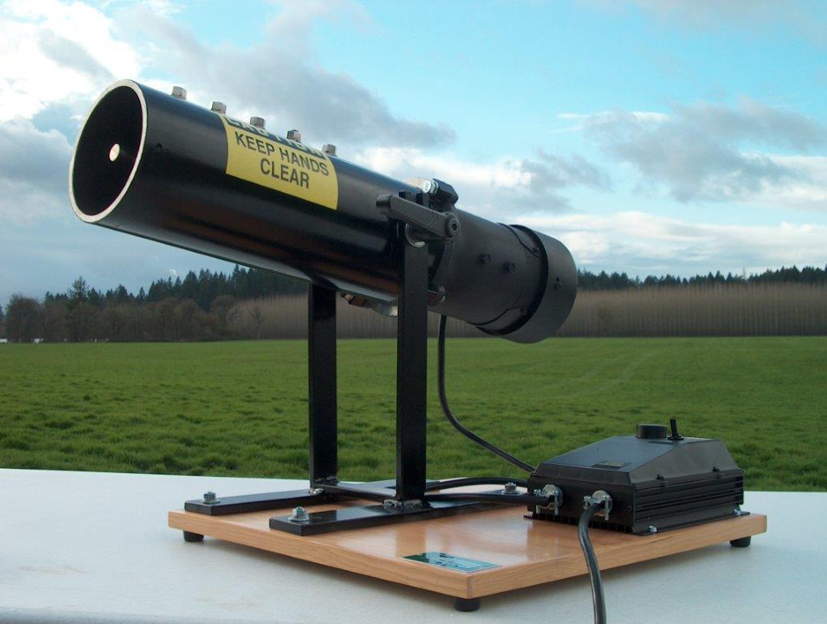
Debearder

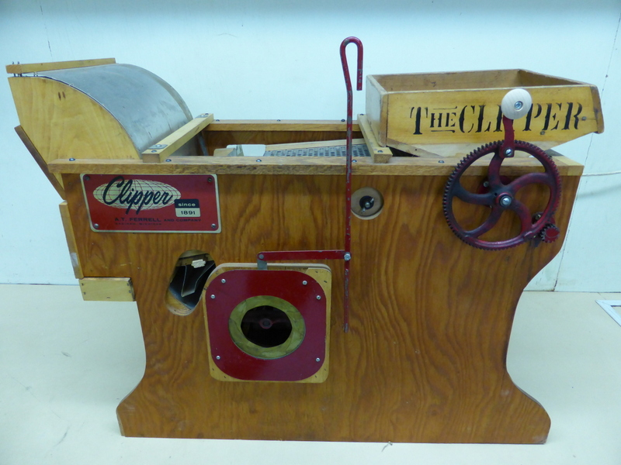
Clipper Office Tester

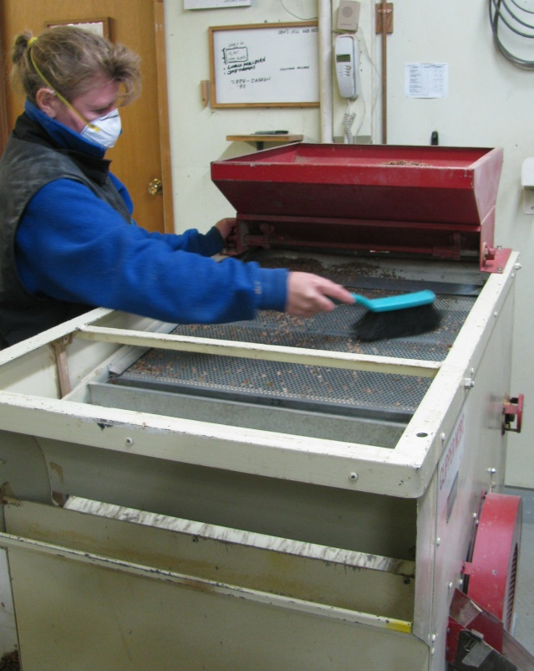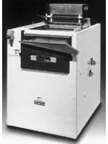
M2B Seed Cleaner Clipper Eclipse 324 Seed Cleaner

Air Separation or Cleaning

Although most seed cleaners have a fan to remove light debris or empty seeds, very precise, final cleaning and the removal of empty seeds can be achieved with an air separator. There are commercially available units ranging in price from $950 US (Hoffman Mfg.) for a very basic model. (See below). There are about $600 in accessories required and the usual shipping and other costs. It can only do very small amounts at one time. Below is a simple homemade air separator that is capable of processing reasonably large size quantities of seed. The cost of the materials is under $1200. It should take 2-3 person-days to construct. The costs and major componets suppliers are listed below.

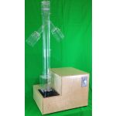
Seed blower from Hoffman Mfg.
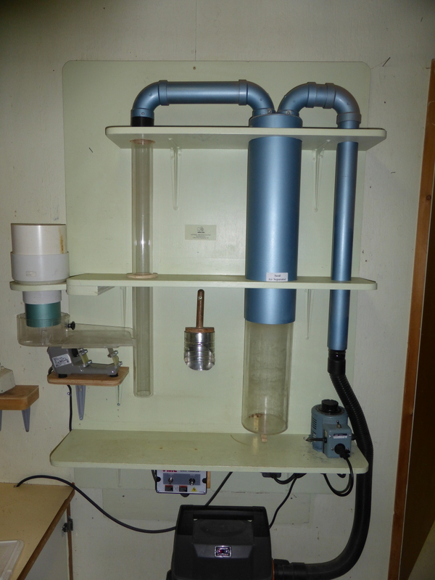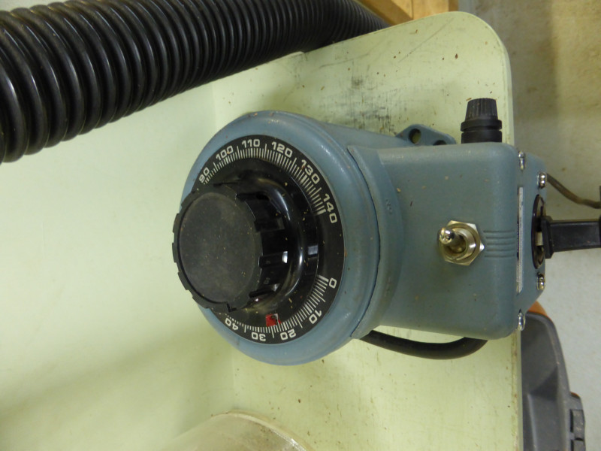
Homemade air separator Variac to control vacuum speed

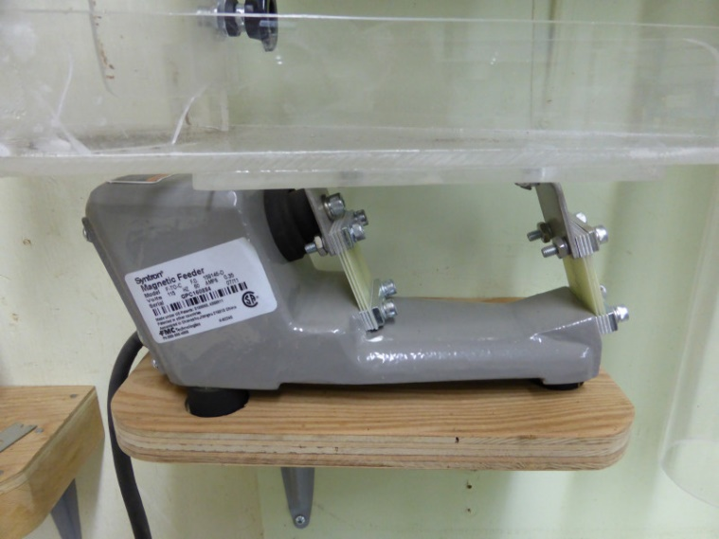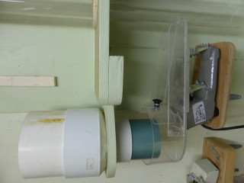

Syntron feeder to regulate the speed of the Seed hopper and feeder assembly.
seed entering the air column.

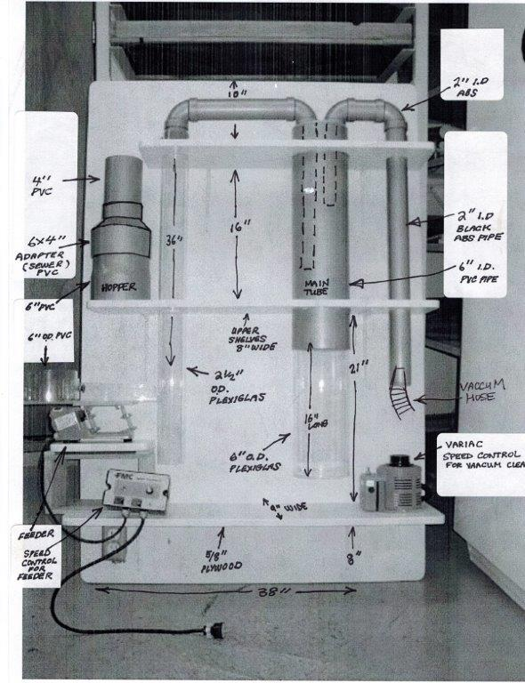

Dimensions of air separator.

Material and Suppliers for Air Separator.

Part | Size | Supplier | Contact | Price | Year of Price
Variac ( controller for vacuum cleaner) 20 amp. | 48-1320 | Main Electronics | 604-872-0267 | $234 | 2011
Feeder- FMC 159146D 115/60HZ FTOC Vibra Drive Unit. |  | Kaman  (Vancouver) | 604-523-2356 | 418 | 2011
Controller- FMC 225484A Power Pulse AC Controller |  | Kaman  (Vancouver) | 604-523-2356 | 202 | 2011
Acrylic tube (Plexiglas) 24” total 16” + feeder part | 6” O.D. | Industrial Plastics Nanaimo | 250-758-1419 | 48 | 2011
Acrylic tube (Plexiglas) 36” | 2 ½” O.D.
ABS pipe (Black) 10’ length. | 2” I.D. | Any plumbing or building supply store. | may have to buy longer pc.  Look for short scraps. | 60  approx.
PVC pipe (White) 24” | 6” I.D.
PVC “ 6” | 6” I.D.
PVC “ 4” | 4” I.D.
Plywood : 4 x 8’ x 5/8” |  | Builders supply. | various. | 40
Shop Vac | 4 – 5 gal. | Hardware store. | various. | 50
Miscellaneous: paint, electrical, screws, etc. |  | Hardware store. | various. | 100

Fleshy fruits

Seeds from fleshy fruit can be removed by macerating the fruits or berries in a household blender which costs from $30 – 200; or with a larger commercial macerator called a Dybvig which cost about $2895 US. Contact bob@dybvigseedcleaner.com or 503-741-6077.

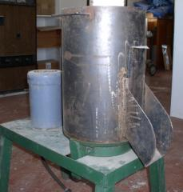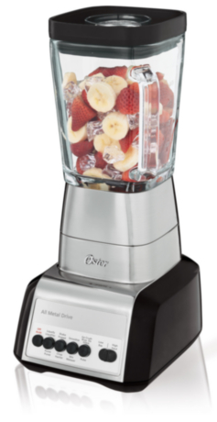
Dybvig Seed Cleaner/ macerator. Oster blender ($79)
Seed Testing

Once the seed has been cleaned and is ready for storage testing is required to ensure that the germination is adequate for sowing.
Seeds can be tested in containers at room temperature where adequate moisture, and light is supplied (8 hours of daylight). Controlled environment chambers provide optimal temperature, moisture and conditions for germination and give you a better idea of the total germination potential.
Desk-top germinators cost about $4800 dollars, and larger models can cost over $10,000. The acrylic germination trays shown below cost less than $1.50 landed here, and the absorbent germination media (Kimpac) and filter paper costs very little per unit, but must be ordered in quantity.

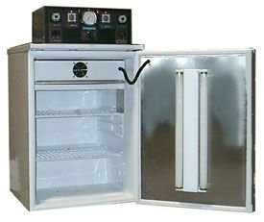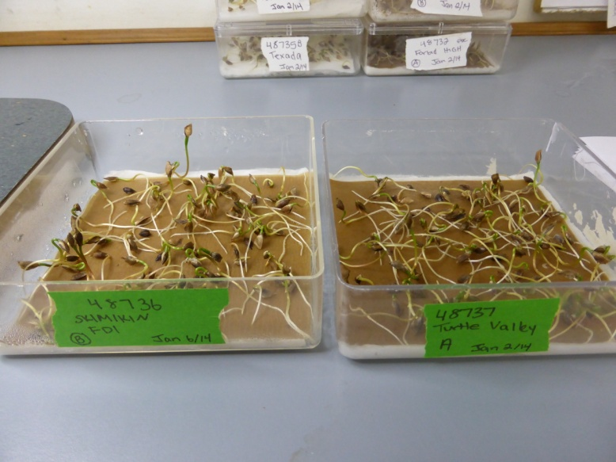

Table top germinator (Seedburo) 4” x 4” acryllic seed germination trays

